Complete Mix wise Grain Data Rejection Analysis

We have plotted Mix wise Grain Rejection data using np-chart and found that Mean is 3 and Upper Control Limit is 7, Many points are found beyond UCL. After Homogenization we need to remove 28 points. We can conclude that the Process is Out of Control.

In each batch Production No of Grain is 11. So No of Rejection in each batch can be varied between 0-11. 0 means No Rejection. 11 means All are rejected. We can see from the Histogram that out of 271 data 34 times there was no Rejection.

We have tried to check whether the data fits Binomial Distribution with failure proportion 0.274, but found large difference between Expected and Observed frequency, hence very large Chi Square value. We came to conclusion that the failure or rejection doesn’t follow Binomial Distribution.

The Rejection of Pinaka Propellant Grain is not same throughout the year. We analysed and found that No of Rejection is varied Month wise. We have performed LANCESTER IRWIN TEST, Equal proportion t-test and Chi Square test for Homogenization and grouped Month in following way:

1. March, April, May, June (Summer)
2. July, August, September (Monsoon)
3. October, November, December, January, February (Winter)

We need to analyse whether some other factors have effect on Rejection.

1. Average Particle Size of AP Fine Drying Before Mixing

The Specifications’ Limit for Average Particle Size is 7-9. Here from the diagram we can see that few observations are beyond limit.

2. Moisture Content of AP Fine Drying and Moisture Content of AP Coarse Before Mixing

The Specification Limit for both variables is <0.35. In our data for both variable all observations are within 0.20, there is little chance that it can be controlled.

The Correlation coefficient between these two variables is 0.7 implies they are strongly correlated. We have tested whether two samples are from Same Population or not.
We have performed F-test & can conclude that sample Variances are same based on data.
We have performed t-test & can conclude that sample means are same based on data.
Both samples are from same Population of equal mean and variance.
3. Volatile Matter % of Aluminium Powder Before Mixing

The Specification Limit for Volatile Matter is <0.2. from the observation we can say that it has large variability. Maximum Observations less than 0.05 is causing more no of Rejections.

4. Moisture Content % of Iron Oxide Before Mixing

The Specification Limit for Moisture Content due to Iron Oxide is <0.5. All observations are within 0.40

5. Slurry Moisture Content % After Mixing
The Specification Limit for both variables is <0.5. All observations are within 0.30

The Correlation coefficient between these two variables is 0.95 implies they are strongly
correlated. We have tested whether two samples are from Same Population or not.
We have performed F-test & can conclude that sample Variances are same based on data.
We have performed t-test & can conclude that sample means are same based on data.
Both samples are from same Population of equal mean and variance.

6. VISCOSITY (Kps) After Mixing
The Specification Limit for Viscosity is <10. But all observations are within 3.84.

Clearly this can be analysed with converting it into two Categories (<3 & 3-4).

RESPONSE (NO OF REJECTIONS)
Possible No of Rejection can be varying from 0 to 11.
We have Classified Rejection into 2 classes: LOW REJECTION (0-2) & HIGH REJECTION (3-11).

RELATION BETWEEN MONTH & RESPONSE
MONTH * REJECTION Crosstabulation
 |  |  | rejected |  | Total
 |  |  | Low | High
MONTH | Summer | Count | 64 | 28 | 92
MONTH |  | % within MONTH(Summer) | 69.60% | 30.40% | 100.00%
MONTH | Monsoon | Count | 29 | 61 | 90
MONTH |  | % within MONTH(Rain) | 32.20% | 67.80% | 100.00%
MONTH | Winter | Count | 53 | 36 | 89
MONTH |  | % within MONTH(Winter) | 59.60% | 40.40% | 100.00%
Total |  | Count | 146 | 125 | 271
 |  | % within MONTH | 53.90% | 46.10% | 100.00%

We have performed Chi Square test for Independence & found Chi Square Value 27.248 which is more than Chi Square with 2 degrees of freedom. So, Month & Response is dependent.

RELATION BETWEEN Average Particle Size of AP Fine Drying & RESPONSE

particle size * Rejected Crosstabulation
 |  |  | rejected |  | Total
Particle size |  |  | LOW | HIGH
Particle size | <8 | Count | 46 | 38 | 84
Particle size |  | % within particle size | 54.80% | 45.20% | 100.00%
Particle size | >8 | Count | 100 | 87 | 187
Particle size |  | % within particle size | 53.50% | 46.50% | 100.00%
Total |  | Count | 146 | 125 | 271
 |  | % within particle size | 53.90% | 46.10% | 100.00%

We have performed Chi Square test for Independence & found Chi Square Value 0.039 which is less than Chi Square with 1 degrees of freedom. So, Particle Size & Response is independent.

Risk Estimate
 | Value | 95% Confidence Interval
 |  | Lower | Upper
Odds Ratio for particle size (.0 / 1.0) | 1.053 | 0.628 | 1.766
RELATION BETWEEN Volatile Matter Aluminium Powder & RESPONSE

VM * Rejected Crosstabulation
 |  |  | rejected |  | Total
VM |  |  | LOW | HIGH
VM | <.05 | Count | 62 | 75 | 137
VM |  | % within VM | 45.30% | 54.70% | 100.00%
VM | >.05 | Count | 84 | 50 | 134
VM |  | % within VM | 62.70% | 37.30% | 100.00%
Total |  | Count | 146 | 125 | 271
 |  | % within VM | 53.90% | 46.10% | 100.00%

We have performed Chi Square test for Independence & found Chi Square Value 8.283
which is more than Chi Square with 1 degrees of freedom. So, VM & Response is dependent.

Risk Estimate
 | Value | 95% Confidence Interval
 |  | Lower | Upper
Odds Ratio for VM  (.0 / 1.0) | 0.492 | 0.303 | 0.8

Rejection depends upon Month & Volatile Matter of Aluminium Powder. Rainy Season (July, August, September) is more prone to high rejection & VM% <0.05 is also a reason for high rejection.

VM * Rejected * MONTH Crosstabulation
MONTH |  |  |  | Rejected |  | Total
 |  |  |  | LOW | HIGH
0 | VM | <=0.05 | Count | 31 | 13 | 44
0 |  |  | % within VM | 70.50% | 29.50% | 100.00%
0 |  | >0.05 | Count | 33 | 15 | 48
0 |  |  | % within VM | 68.80% | 31.30% | 100.00%
0 | Total |  | Count | 64 | 28 | 92
 |  |  | % within VM | 69.60% | 30.40% | 100.00%
1 | VM | <=0.05 | Count | 16 | 49 | 65
1 |  |  | % within VM | 24.60% | 75.40% | 100.00%
1 |  | >0.05 | Count | 13 | 12 | 25
1 |  |  | % within VM | 52.00% | 48.00% | 100.00%
1 | Total |  | Count | 29 | 61 | 90
 |  |  | % within VM | 32.20% | 67.80% | 100.00%
2 | VM | <=0.05 | Count | 15 | 13 | 28
2 |  |  | % within VM | 53.60% | 46.40% | 100.00%
2 |  | >0.05 | Count | 38 | 23 | 61
2 |  |  | % within VM | 62.30% | 37.70% | 100.00%
2 | Total |  | Count | 53 | 36 | 89
 |  |  | % within VM | 59.60% | 40.40% | 100.00%
Total | VM | <=0.05 | Count | 62 | 75 | 137
 |  |  | % within VM | 45.30% | 54.70% | 100.00%
 |  | >0.05 | Count | 84 | 50 | 134
 |  |  | % within VM | 62.70% | 37.30% | 100.00%
 | Total |  | Count | 146 | 125 | 271
 |  |  | % within VM | 53.90% | 46.10% | 100.00%

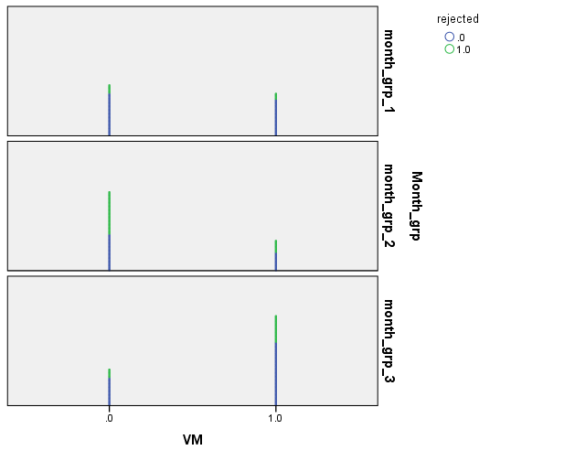
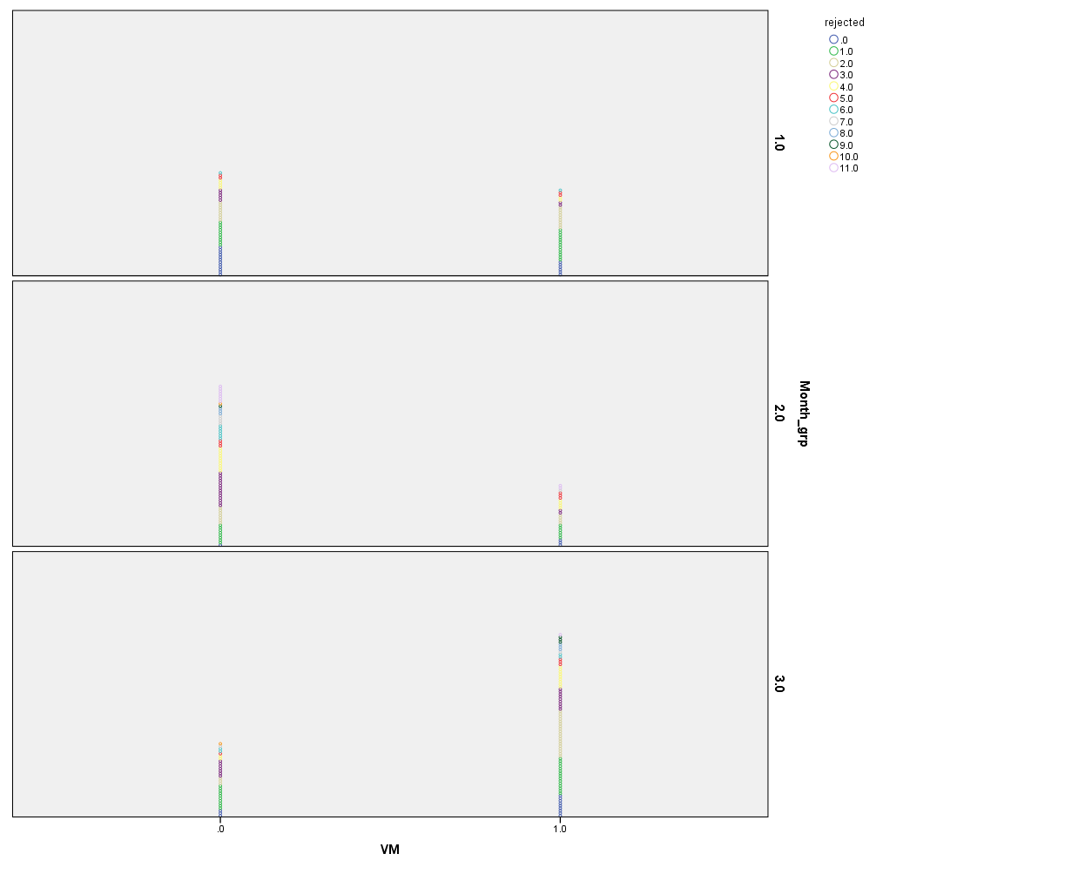

There is interaction between Volatile Matter % & Season. Chi Square Calculated value 30.148 is higher than Chi Square observed for degrees of freedom 2.

Correlation among Variables:

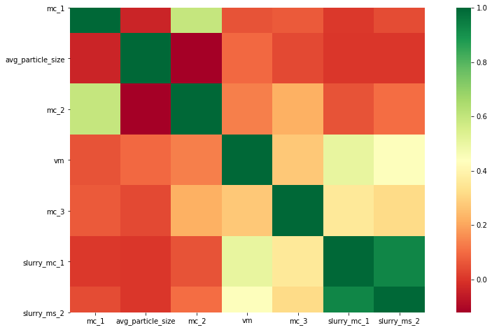

LOGIT MODEL(BINOM) FITTING

Results: Generalized linear model
===============================================================
Model: GLM AIC: 351.4535
Link Function: logit BIC: -1152.3122
Dependent Variable: rejected Log-Likelihood: -171.73
Date: 2020-06-14 19:11 LL-Null: -187.03
No. Observations: 271 Deviance: 343.45
Df Model: 3 Pearson chi2: 271.
Df Residuals: 267 Scale: 1.0000
Method: IRLS
----------------------------------------------------------------
Coef. Std Err. z P>|z| [0.025 0.975]
----------------------------------------------------------------
constant -0.0761 0.2831 -0.2689 0.7880 -0.6309 0.4787
VM% -0.4587 0.2708 -1.6939 0.0903 -0.9895 0.0721
SUMMER -0.5215 0.3191 -1.6342 0.1022 -1.1469 0.1039
MONSOON 0.9542 0.3289 2.9006 0.0037 0.3094 1.5989

Results: Generalized linear model
===============================================================
Model: GLM AIC: 348.3367
Link Function: logit BIC: -1159.0312
Dependent Variable: rejected Log-Likelihood: -171.17
Date: 2020-06-14 19:18 LL-Null: -187.03
No. Observations: 271 Deviance: 342.34
Df Model: 2 Pearson chi2: 271.
Df Residuals: 268 Scale: 1.0000
Method: IRLS
----------------------------------------------------------------
Coef. Std Err. z P>|z| [0.025 0.975]
----------------------------------------------------------------
constant -0.6033 0.1555 -3.8803 0.0001 -0.9080 -0.2986
MONSOON 1.7225 0.3272 5.2639 0.0000 1.0812 2.3639
MONSOON*VM -1.1993 0.4931 -2.4320 0.0150 -2.1658 -0.2328
===============================================================

This is clear that only MONSOON & INTERACTION BETWEEN MONSOON & VM% is important. Other terms are insignificant.

Av. Particle Size * rejected * Month grp Crosstabulation
Month grp |  |  |  | rejected |  | Total
 |  |  |  | LOW | HIGH
SUMMER | Av. Particle Size | <8 | Count | 19 | 5 | 24
 |  |  | % within Av. Particle Size | 79.20% | 20.80% | 100.00%
 |  | >8 | Count | 46 | 7 | 53
 |  |  | % within Av. Particle Size | 86.80% | 13.20% | 100.00%
 | Total |  | Count | 65 | 12 | 77
 |  |  | % within Av. Particle Size | 84.40% | 15.60% | 100.00%
MONSOON | Av. Particle Size | <8 | Count | 19 | 11 | 30
 |  |  | % within Av. Particle Size | 63.30% | 36.70% | 100.00%
 |  | >8 | Count | 26 | 34 | 60
 |  |  | % within Av. Particle Size | 43.30% | 56.70% | 100.00%
 | Total |  | Count | 45 | 45 | 90
 |  |  | % within Av. Particle Size | 50.00% | 50.00% | 100.00%
WINTER | Av. Particle Size | <8 | Count | 24 | 6 | 30
 |  |  | % within Av. Particle Size | 80.00% | 20.00% | 100.00%
 |  | >8 | Count | 51 | 23 | 74
 |  |  | % within Av. Particle Size | 68.90% | 31.10% | 100.00%
 | Total |  | Count | 75 | 29 | 104
 |  |  | % within Av. Particle Size | 72.10% | 27.90% | 100.00%
Total | Av. Particle Size | <8 | Count | 62 | 22 | 84
 |  |  | % within Av. Particle Size | 73.80% | 26.20% | 100.00%
 |  | >8 | Count | 123 | 64 | 187
 |  |  | % within Av. Particle Size | 65.80% | 34.20% | 100.00%
 | Total |  | Count | 185 | 86 | 271
 |  |  | % within Av. Particle Size | 68.30% | 31.70% | 100.00%

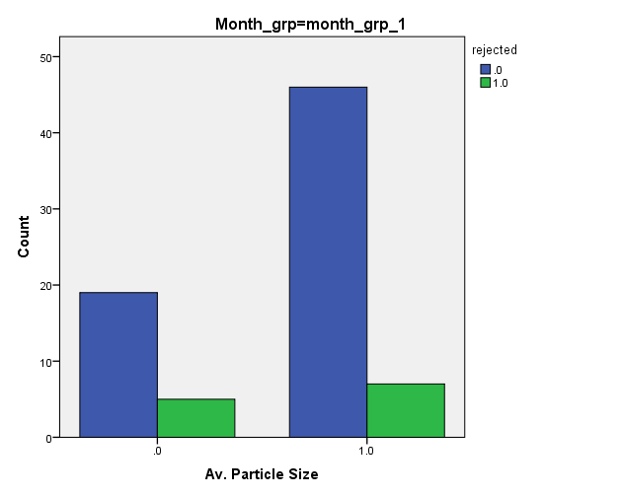

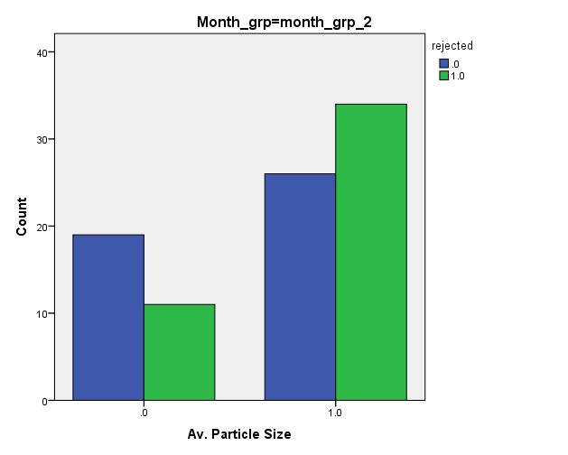

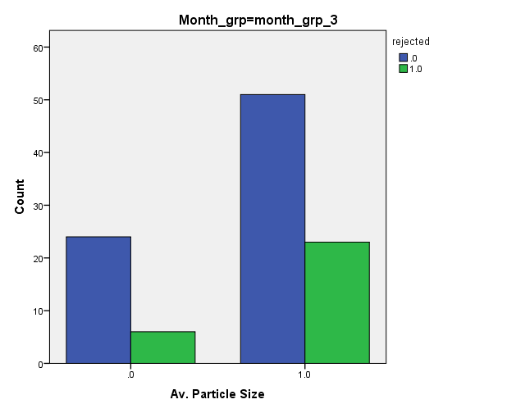
FAILURE PROPORTION IN WINTER

WINTER | NO OF DEFECTS | OBSERVED FREQUENCY | xi fi | PROB | EXPECTED FREQUENCY
 | 0 | 12 | 0 | 0.039605 | 4.12
 | 1 | 25 | 25 | 0.148624 | 15.46
 | 2 | 22 | 44 | 0.253515 | 26.37
 | 3 | 16 | 48 | 0.259459 | 26.98
 | 4 | 11 | 44 | 0.177029 | 18.41
 | 5 | 4 | 20 | 0.084551 | 8.79
 | 6 | 4 | 24 | 0.028844 | 3.00
 | 7 | 2 | 14 | 0.007029 | 0.73
 | 8 | 3 | 24 | 0.001199 | 0.12
 | 9 | 3 | 27 | 0.000136 | 0.01
 | 10 | 1 | 10 | 9.3E-06 | 0.00
 | 11 | 1 | 11 | 2.88E-07 | 0.00
SUM |  | 104 | 291 | 1 | 104

WINTER | NO OF DEFECTS | OBSERVED FREQUENCY | EXPECTED FREQUENCY | (O-E)^2 | CHI SQUARE
 | 0 | 12 | 4.12 | 62.11 | 15.08
 | 1 | 25 | 15.46 | 91.07 | 5.89
 | 2 | 22 | 26.37 | 19.06 | 0.72
 | 3 | 16 | 26.98 | 120.64 | 4.47
 | 4 | 11 | 18.41 | 54.92 | 2.98
 | 5 & ABOVE | 18 | 12.66 | 28.52 | 2.25
 |  | 104 | 103.9960643 | 376.3217 | 31.4008029

Defects in Winter is following Binomial Distribution with rejection proportion 0.254.

FAILURE PROPORTION IN SUMMER

SUMMER | NO OF DEFECTS | OBSERVED FREQUENCY | xi fi | PROB | EXPECTED FREQUENCY
 | 0 | 18 | 0 | 0.15 | 11.61
 | 1 | 23 | 23 | 0.31 | 23.97
 | 2 | 17 | 34 | 0.29 | 22.49
 | 3 | 7 | 21 | 0.16 | 12.66
 | 4 | 6 | 24 | 0.06 | 4.75
 | 5 | 4 | 20 | 0.02 | 1.25
 | 6 | 2 | 12 | 0.00 | 0.23
SUM |  | 77 | 134 | 1.00 | 76.97

SUMMER | NO OF DEFECTS | OBSERVED FREQUENCY | EXPECTED FREQUENCY | (O-E)^2 | CHI SQUARE
 | 0 | 18 | 11.61 | 40.80 | 3.51
 | 1 | 23 | 23.97 | 0.94 | 0.04
 | 2 | 17 | 22.49 | 30.13 | 1.34
 | 3 | 7 | 12.66 | 32.04 | 2.53
 | 4 & ABOVE | 12 | 6.23 | 33.29 | 5.34
 |  |  |  |  | 12.77

Defects in Summer is following Binomial Distribution with rejection proportion 0.158

FAILURE PROPORTION IN MONSOON

MONSOON | NO OF DEFECTS | OBSERVED FREQUENCY | xi fi | PROB | EXPECTED FREQUENCY
 | 0 | 4 | 0 | 0.004593 | 0.41
 | 1 | 14 | 14 | 0.031894 | 2.87
 | 2 | 11 | 22 | 0.100677 | 9.06
 | 3 | 16 | 48 | 0.190678 | 17.16
 | 4 | 14 | 56 | 0.240758 | 21.67
 | 5 | 6 | 30 | 0.212794 | 19.15
 | 6 | 6 | 36 | 0.134341 | 12.09
 | 7 | 5 | 35 | 0.06058 | 5.45
 | 8 | 3 | 24 | 0.019123 | 1.72
 | 9 | 1 | 9 | 0.004024 | 0.36
 | 10 | 1 | 10 | 0.000508 | 0.05
 | 11 | 9 | 99 | 2.92E-05 | 0.00
SUM |  | 90 | 383 | 1 | 90

MONSOON | NO OF DEFECTS | OBSERVED FREQUENCY | EXPECTED FREQUENCY | (O-E)^2 | CHI SQUARE
 | 0 | 4 | 0.41 | 12.86 | 31.12
 | 1 | 14 | 2.87 | 123.87 | 43.15
 | 2 | 11 | 9.06 | 3.76 | 0.41
 | 3 | 16 | 17.16 | 1.35 | 0.08
 | 4 | 14 | 21.67 | 58.80 | 2.71
 | 5 | 6 | 19.15 | 172.96 | 9.03
 | 6 | 6 | 12.09 | 37.10 | 3.07
 | 7 & ABOVE | 19 | 7.58 | 130.42 | 17.21
 |  |  |  |  | 106.79

Defects in Monsoon doesn’t follow Binomial Distribution with rejection proportion 0.387 which is very high.

RADIOGRAPHY DATA EXPLORATORY ANALYSIS
1) Month vs Cause crosstabulation

 | Cause
Month | Cracks | H D I | Others | Surface  area | marginal  total
January | 26 | 9 | 9 | 22 | 66
February | 27 | 3 | 5 | 17 | 52
march | 32 | 1 | 13 | 9 | 55
April | 9 | 5 | 11 | 3 | 28
may | 17 | 10 | 7 | 0 | 34
June | 31 | 2 | 15 | 0 | 48
July | 45 | 4 | 5 | 9 | 63
august | 73 | 3 | 6 | 17 | 99
September | 45 | 7 | 3 | 2 | 57
October | 38 | 2 | 4 | 4 | 48
November | 10 | 0 | 0 | 3 | 13
December | 23 | 4 | 4 | 4 | 35
Marginal total | 376 | 50 | 82 | 90 | 598

 | Cause
Month | Cracks | H D I | Others | Surface  area | marginal  total
Summer | 89 | 18 | 46 | 12 | 165
Monsoon | 163 | 14 | 14 | 28 | 219
Winter | 124 | 18 | 22 | 50 | 214
marginal total | 376 | 50 | 82 | 90 | 598

2) Month group vs X-ray stage Cross-tabulation

Month group | X-ray stage
Month group | BARE NDT | INHIBITED  NDT
0 | 27 | 138
1 | 48 | 171
2 | 61 | 153
3) Segment No vs Cause crosstabulation
 | cause
Segment No | Cracks | H D I | Others | Surface  area | marginal  total
1 | 49 | 5 | 14 | 4 | 72
2 | 31 | 7 | 7 | 0 | 45
3 | 33 | 7 | 6 | 4 | 50
4 | 35 | 7 | 3 | 6 | 51
5 | 160 | 10 | 32 | 13 | 215
- | 40 | 7 | 11 | 31 | 89
1 & 2 | 3 | 0 | 0 | 0 | 3
1 & 3 | 2 | 0 | 0 | 0 | 2
1 & 5 | 3 | 0 | 1 | 0 | 4
2 & 4 | 2 | 0 | 0 | 0 | 2
2 & 5 | 2 | 0 | 1 | 0 | 3
3 & 4 | 1 | 1 | 0 | 0 | 2
3 & 5 | 4 | 1 | 0 | 0 | 5
4 & 5 | 9 | 0 | 1 | 1 | 11
All segment | 0 | 0 | 1 | 0 | 1
marginal total | 374 | 45 | 77 | 59 | 555
43 values are missing in this case (555+43 = 598)
missing values | 2 | 5 | 5 | 31 | 43

4) X-ray vs Grain No crosstabulation

X-ray stage | Grain no group
X-ray stage | Front | Rear | All
BARE NDT | 54 | 82 | 136
INHIBITED NDT | 259 | 203 | 462
ALL | 313 | 285 | 598

5) 3 Way Contingency Table

Month | Cause | Grain location |  | All
Month | Cause | Front | Rear | All
Summer | Cracks | 41 | 48 | 89
Summer | H D I | 11 | 7 | 18
Summer | Others | 20 | 26 | 46
Summer | Surface  area | 2 | 10 | 12
Monsoon | Cracks | 106 | 57 | 163
Monsoon | H D I | 7 | 7 | 14
Monsoon | Others | 3 | 11 | 14
Monsoon | Surface  area | 13 | 15 | 28
Winter | Cracks | 74 | 50 | 124
Winter | H D I | 5 | 13 | 18
Winter | Others | 7 | 15 | 22
Winter | Surface  area | 24 | 26 | 50
All |  | 313 | 285 | 598

6) X-ray vs Grain No cross-tabulation

X Ray Stage * Cause Group Crosstabulation
 |  |  | Cause Group |  |  |  | Total
 |  |  | crack | high density inclusion | others | surface area
X Ray Stage | bare NDT | Count | 48 | 13 | 13 | 62 | 136
X Ray Stage |  | % within X Ray Stage | 35.30% | 9.60% | 9.60% | 45.60% | 100.00%
X Ray Stage | inhibited NDT | Count | 328 | 37 | 69 | 28 | 462
X Ray Stage |  | % within X Ray Stage | 71.00% | 8.00% | 14.90% | 6.10% | 100.00%
Total |  | Count | 376 | 50 | 82 | 90 | 598
 |  | % within X Ray Stage | 62.90% | 8.40% | 13.70% | 15.10% | 100.00%

Chi-Square Tests
 | Value | df | Asymptotic Sig. (2-sided)
Pearson Chi-Square | 132.895a | 3 | 0
Likelihood Ratio | 113.422 | 3 | 0

1) Month vs Cause crosstabulation

month * Cause Group Crosstabulation
 |  |  | Cause Group |  |  |  | Total
 |  |  | crack | high density inclusion | others | surface area
month | 0 | Count | 88 | 18 | 45 | 12 | 163
month |  | % within month | 54.00% | 11.00% | 27.60% | 7.40% | 100.00%
month | 1 | Count | 164 | 14 | 15 | 28 | 221
month |  | % within month | 74.20% | 6.30% | 6.80% | 12.70% | 100.00%
month | 2 | Count | 124 | 18 | 22 | 50 | 214
month |  | % within month | 57.90% | 8.40% | 10.30% | 23.40% | 100.00%
Total |  | Count | 376 | 50 | 82 | 90 | 598
 |  | % within month | 62.90% | 8.40% | 13.70% | 15.10% | 100.00%

Chi-Square Tests
 | Value | df | Asymptotic Sig. (2-sided)
Pearson Chi-Square | 59.458a | 6 | 0
Likelihood Ratio | 56.113 | 6 | 0

month |  |  |  | Cause Group |  |  |  | Total
 |  |  |  | crack | HDI | others | surface area
Summer | X Ray Stage | bare NDT | Count | 6 | 5 | 9 | 7 | 27
 |  |  | % within X Ray Stage | 22.20% | 18.50% | 33.30% | 25.90% | 100.00%
 |  | inhibited NDT | Count | 82 | 13 | 36 | 5 | 136
 |  |  | % within X Ray Stage | 60.30% | 9.60% | 26.50% | 3.70% | 100.00%
 | Total |  | Count | 88 | 18 | 45 | 12 | 163
 |  |  | % within X Ray Stage | 54.00% | 11.00% | 27.60% | 7.40% | 100.00%
Monsoon | X Ray Stage | bare NDT | Count | 21 | 2 | 2 | 23 | 48
 |  |  | % within X Ray Stage | 43.80% | 4.20% | 4.20% | 47.90% | 100.00%
 |  | inhibited NDT | Count | 143 | 12 | 13 | 5 | 173
 |  |  | % within X Ray Stage | 82.70% | 6.90% | 7.50% | 2.90% | 100.00%
 | Total |  | Count | 164 | 14 | 15 | 28 | 221
 |  |  | % within X Ray Stage | 74.20% | 6.30% | 6.80% | 12.70% | 100.00%
Winter | X Ray Stage | bare NDT | Count | 21 | 6 | 2 | 32 | 61
 |  |  | % within X Ray Stage | 34.40% | 9.80% | 3.30% | 52.50% | 100.00%
 |  | inhibited NDT | Count | 103 | 12 | 20 | 18 | 153
 |  |  | % within X Ray Stage | 67.30% | 7.80% | 13.10% | 11.80% | 100.00%
 | Total |  | Count | 124 | 18 | 22 | 50 | 214
 |  |  | % within X Ray Stage | 57.90% | 8.40% | 10.30% | 23.40% | 100.00%
Total | X Ray Stage | bare NDT | Count | 48 | 13 | 13 | 62 | 136
 |  |  | % within X Ray Stage | 35.30% | 9.60% | 9.60% | 45.60% | 100.00%
 |  | inhibited NDT | Count | 328 | 37 | 69 | 28 | 462
 |  |  | % within X Ray Stage | 71.00% | 8.00% | 14.90% | 6.10% | 100.00%
 | Total |  | Count | 376 | 50 | 82 | 90 | 598
 |  |  | % within X Ray Stage | 62.90% | 8.40% | 13.70% | 15.10% | 100.00%

Grain Fault Position (Front/Rear) and Fault type is independent.

Fault Position and X-ray stage is dependent.
Fault Position and Month is independent

